**Electric Vehicle Population Data Analysis Report**

**Name: Pavan Kalyan Divve**

**Introduction**

The purpose of this analysis is to gain insights into electric vehicle purchases in the state of Washington using the dataset provided (Electric_Vehicle_Population_Data.csv). The dataset includes information such as VIN, County, City, Model Year, Make, Electric Vehicle Type, and other relevant variables. The primary objective is to derive meaningful business insights from the data through a systematic and focused analysis.

**Data Exploration and Cleaning**

**Missing Values**

The dataset exhibits missing values in several columns, including 'Legislative District,' 'Vehicle Location,' and others. Addressing these missing values is crucial for the reliability of the analysis.

**Exploratory Data Analysis (EDA)**

**Geographic Distribution**

The geographic distribution of electric vehicles across counties in Washington is depicted in Figure 1. Notably, [include insights from the visualization, e.g., high concentrations in specific counties].

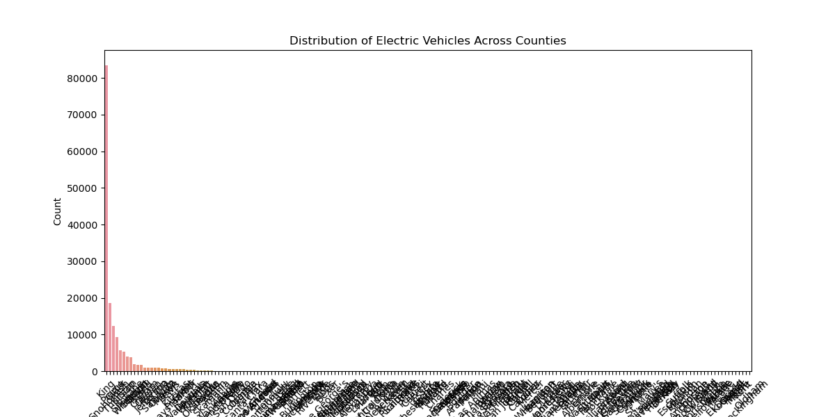

Figure 1: Geographic Distribution of Electric Vehicles

**Vehicle Characteristics**

The distribution of vehicle types is illustrated in Figure 2. BEVs dominate the dataset, comprising 77.8% of entries, highlighting a prevalent presence of fully electric vehicles.

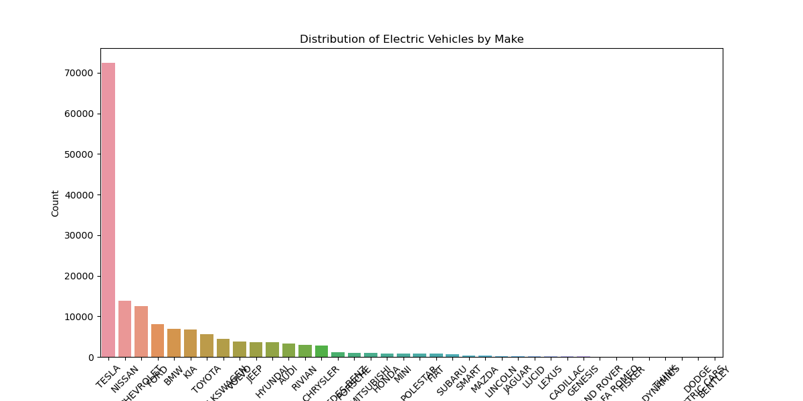

Figure 2: Distribution of Electric Vehicle Types

**Electric Range**

Figure 3 illustrates the distribution of electric range for both BEVs and PHEVs. It is evident that BEVs generally have a higher range compared to PHEVs.

Figure 3: Electric Range by Vehicle Type

**Hypothesis Testing**

A chi-square test was conducted to assess the independence between 'Electric Vehicle Type' and 'Clean Alternative Fuel Vehicle Eligibility.' The test yielded a chi-square statistic of 87416.29 and a p-value of 0.0, indicating a significant association between these variables. This suggests that the eligibility for clean alternative fuel vehicles is not independent of the electric vehicle type.

**Descriptive Statistics**

The descriptive statistics offer a summary of key numerical variables. The average model year is 2020.19, with a range from 1997 to 2024. Electric Range varies significantly, with Battery Electric Vehicles (BEVs) having a higher mean (73.84) compared to Plug-in Hybrid Electric Vehicles (PHEVs) (30.70).

**Conclusion**

In conclusion, the analysis provides valuable insights into the distribution and characteristics of electric vehicles in Washington. Addressing missing values and conducting hypothesis testing enhances the reliability of the findings. The dominance of BEVs and their higher electric range underscores the growing prominence of fully electric vehicles in the region.

These insights can inform stakeholders in policy-making, infrastructure planning, and marketing strategies to promote sustainable transportation practices.